UID – **19BEC1117**

**Exp. No : 4** **Design automatic led Diwali lights (consisting of 6 led’s) such that it only works during night and can generate two patterns which can be toggled with switch. a. Pattern 1 – led blinks with a freq. of 500 msec. b. Pattern 2 – led blinks with a freq. of 1 sec**

**THEORY**

**Circuit Diagram :**

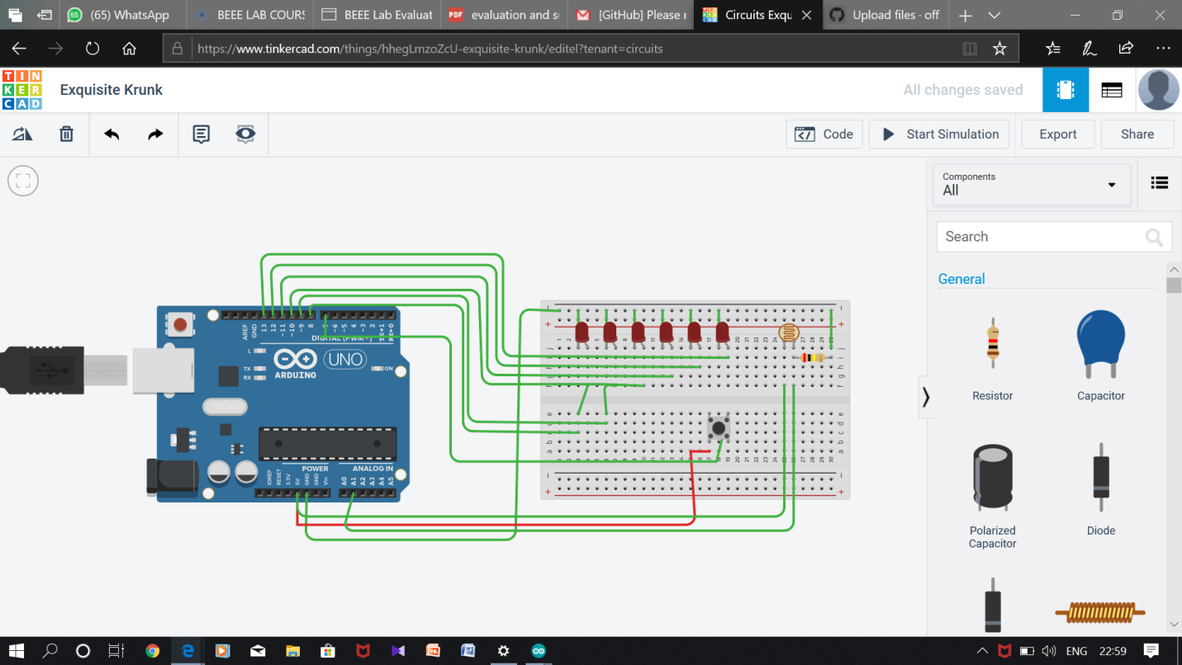

**Concepts : When** the LDR sets to low it aloows the flow of electricity through the leds and the pattern of blink alters when we press the button.

**Learning And Observation**: I learnt to connect arduino with LDR ,button and LEDS. I observed that when the Light Dependent Resistor(LDR) input signal can be programmed to control the flow of electricity through LEDS and The pattern of flow of charge can be changed or altered using a push button**.**

**CODE:**

**void setup()**

**{**

**pinMode(13, OUTPUT);**

**pinMode(12,OUTPUT);**

**pinMode(11, OUTPUT);**

**pinMode(10,OUTPUT);**

**pinMode(9, OUTPUT);**

**pinMode(8,OUTPUT);**

**pinMode(7,INPUT);**

**Serial.begin(9600);**

**}**

**void loop()**

**{**

**int d = analogRead(A1);**

**Serial.println(d);**

**delay(200);**

**if(d>450)**

**{**

**if(digitalRead(7)==HIGH)**

**{**

**digitalWrite(13,HIGH);**

**digitalWrite(12,HIGH);**

**digitalWrite(11,HIGH);**

**digitalWrite(10,HIGH);**

**digitalWrite(9,HIGH);**

**digitalWrite(8,HIGH);**

**delay(500);**

**digitalWrite(13,LOW);**

**digitalWrite(12,LOW);**

**digitalWrite(11,LOW);**

**digitalWrite(10,LOW);**

**digitalWrite(9,LOW);**

**digitalWrite(8,LOW);**

**delay(500);**

**}**

**else**

**{**

**digitalWrite(13,HIGH);**

**digitalWrite(12,HIGH);**

**digitalWrite(11,HIGH);**

**digitalWrite(10,HIGH);**

**digitalWrite(9,HIGH);**

**digitalWrite(8,HIGH);**

**delay(2000);**

**digitalWrite(13,LOW);**

**digitalWrite(12,LOW);**

**digitalWrite(11,LOW);**

**digitalWrite(10,LOW);**

**digitalWrite(9,LOW);**

**digitalWrite(8,LOW);**

**delay(2000);**

**}**

**}**

**}**

1. Faced problem in connecting the LDR with arduino, troubleshooted it by changing the wires connected to GND And Analog INPUTS.
2. Faced Problem in connecting Push Button Switch with Arduino.
3. Faced Problem In connecting The LEDS in Common

Precaution And Troubleshooting:

1. Connecting Wires in Common For GND for All LEDS.
2. Connecting 5V, GND with Analog Input for LDR.

Learning And Outcomes:

To work With LDR And push button With Arduino.